Governor’s Advisory Board for
Telecommunications Relay Agenda
January 14, 2022 • 9:00AM – 12:00PM
Zoom Platform
- Open Meeting (Darrin Smith)
  - Roll Call
  - Approval of October 15, 2021 Minutes
- TAM Staff Reports
  - Director (David Bahar)
  - Maryland Relay Program/GABTR Liaison (Travis Dougherty)
  - MAT Program (Kevin Steffy)
  - Outreach Program (Donna Broadway-Callaman)
  - Finance Update (Leslie Hannibal)
- Break (10 min.)
- GABTR Chairman’s Report (Alfred Sonnenstrahl)
- GABTR Members’ Reports
- Public Input
- New Business
- Announcements
- Adjourn
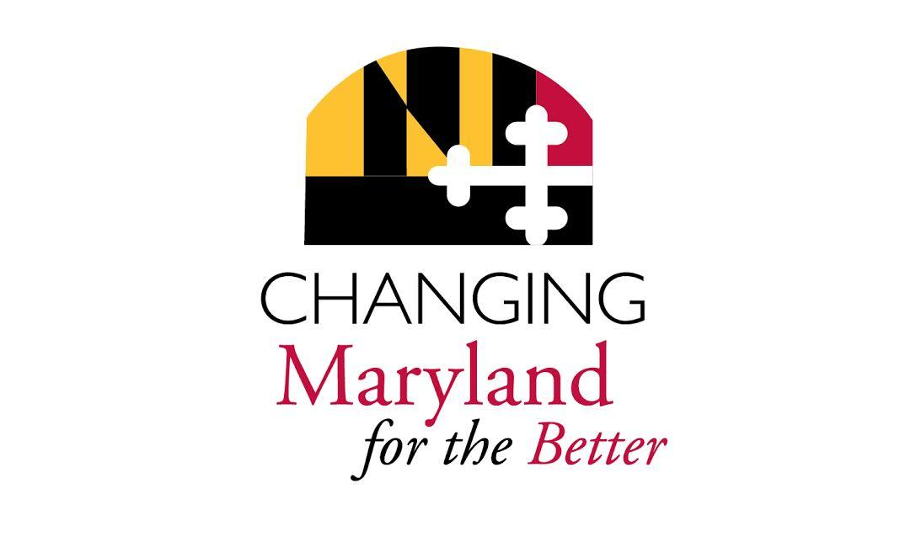
Interpreters: Anna Rose, Anne Leahy,
CART: Natalie Ennis

